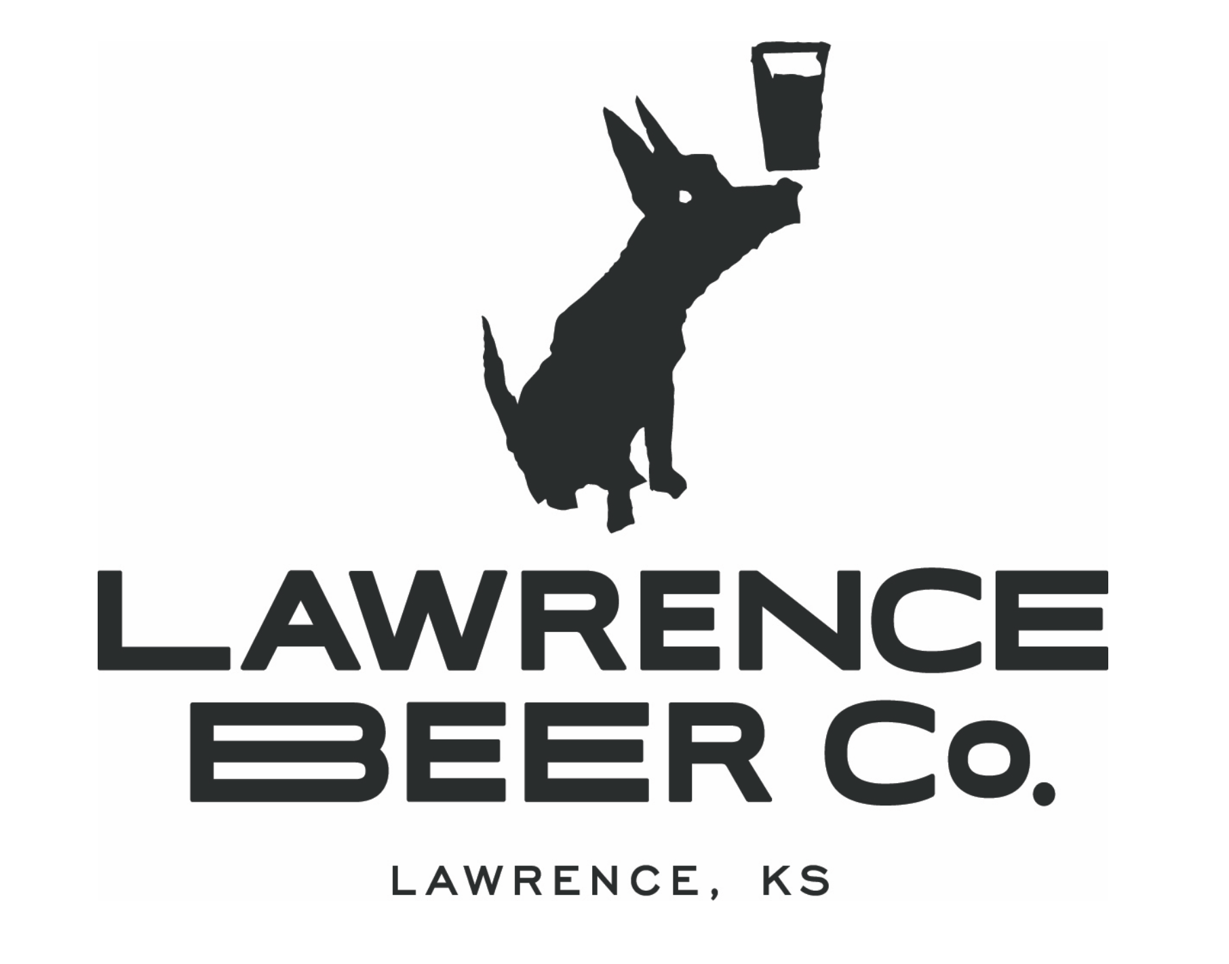  Employment Application |  |  |  |  |  |  |  |  | Lawrence Beer Company is an Equal Opportunity Employer and is committed to excellence through diversity.  In compliance with the Immigration Reform and control Act of 1986, Lawrence Beer Company will hire only U.S. citizens and aliens lawfully authorized to work in the U.S.. |  |  | Please print or type. The application must be fully completed to be considered. Please complete each section, even if you attach a resume.
Personal Information
Name
Address |  |  |  |  |  | City |  |  | State |  |  | Zip
Phone Number |  |  | Mobile Number |  |  | Email Address
Are You a U.S. Citizen? |  |  |  |  |  | Have You Ever Been Convicted Of A Felony? (An answer of “Yes” does not necessarily immediately disqualify your application. All circumstances will be considered).
Yes |  | No |  |  |  | Yes | No If Yes, please explain.
If you are NOT a U.S. Citizen, are you legally authorized to work in the U.S.?  Yes No |  |  |  |  |  | Are you at least 18 years of age? |  | Yes No
Position
Position You Are Applying For |  |  |  |  |  | Available Start Date (August Opening) |  |  |  |  |  | Desired Pay
Shift Availability (Must be available 2+ shifts per week)
 | Monday |  |  | Tuesday | Wednesday |  |  | Thursday |  | Friday | Saturday |  | Sunday
Day
Night
Education
School Name |  |  |  | Location |  | Years Attended |  |  | Degree Received |  |  | Major
[
References
Name |  |  |  |  |  | Title |  |  | Company |  |  | Phone

Employment History – beginning with most recent
Company Name |  | Job Title |  | Dates Employed
Reason for Leaving |  | Starting Pay Rate |  | Ending Pay Rate
Address |  | City | State | Zip
Company Name |  | Job Title |  | Dates Employed
Reason for Leaving |  | Starting Pay Rate |  | Ending Pay Rate
Address |  | City | State | Zip
Company Name |  | Job Title |  | Dates Employed
Reason for Leaving |  | Starting Pay Rate |  | Ending Pay Rate
Address |  | City | State | Zip
Company Name |  | Job Title |  | Dates Employed
Reason for Leaving |  | Starting Pay Rate |  | Ending Pay Rate
Address |  | City | State | Zip
Why do you want to work at Lawrence Beer Company?

What makes you qualified to work here?

Do you know anyone who works here?

In your past experience, what was your favorite job and why?

Please list a few non-work activities you enjoy.

How long have you lived in Lawrence?

What is your favorite thing about Lawrence?

Describe yourself in five words.

Describe your perfect eating and drinking scenario including menu, location, and anyone else involved.

Signature Disclaimer
I certify that my answers are true and complete to the best of my knowledge.
If this application leads to employment, I understand that false or misleading information in my application or interview may result in my release.

Name (Please Print) |  | Signature
Date

